Nama : Samudra Bryandhika Prakoso

Kelas : PPTI 21

NIM : 2802538750

**Palorant**

Giot company just launched their multiplayer tactical first-person shooter game called **Palorant**. The game is set in a near-future world and features a roster of unique characters known as "Agents," each with their own special abilities. Headquartered in Los Angeles, California, Giot has established **Palorant** as a competitive esports title, recognized for its strategic gameplay and precise gun mechanics.

Due to its recent release, many players are struggling to understand the various elements and mechanics of the game. To address this, **Palorant** is planning to develop **a website prototype** and **a game website** that provides detailed information about the game. The initial focus will be on designing a prototype for the website that reflects the game's dynamic and competitive spirit. The goal is to enhance the player experience by offering a user-friendly platform where players can find all the necessary information. **Palorant** has chosen you as the trusted web designer to conceptualize the website prototype and build the official game website.

Canva element :

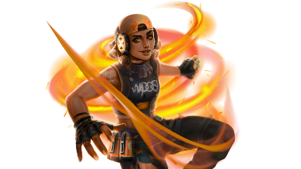

Link : <https://wallpapersden.com/raze-new-valorant-wallpaper/>

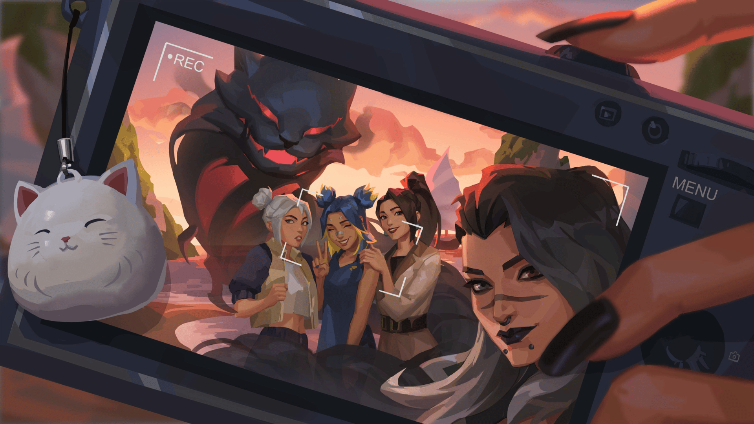

Link : <https://wallpapersden.com/valorant-hd-selfiee-wallpaper/>

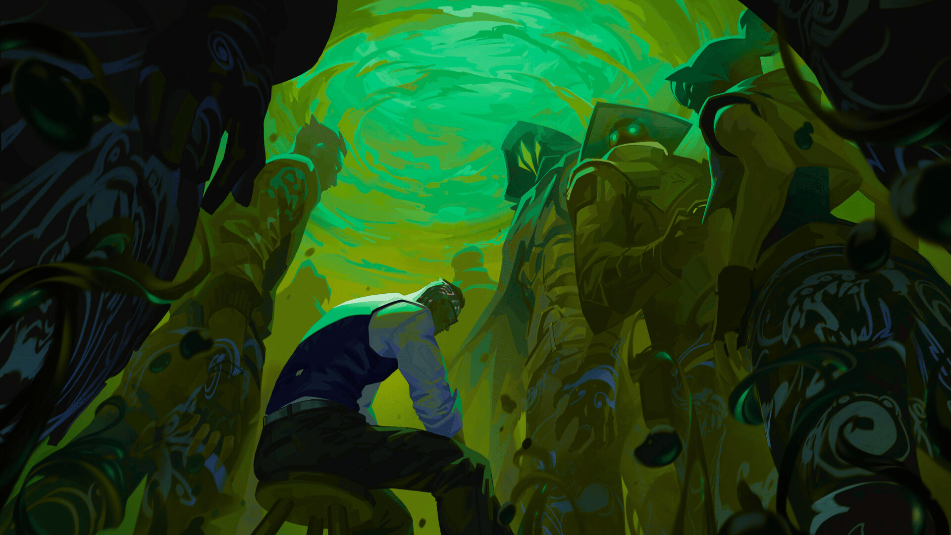

Link : <https://wallpapersden.com/valorant-hd-cool-digital-2022-art-wallpaper/>

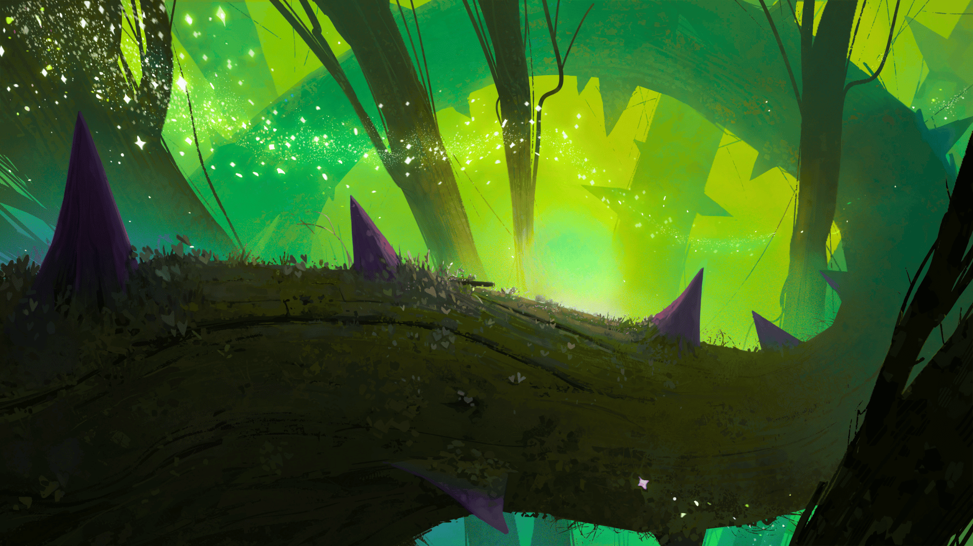

Link : <https://wallpapersden.com/searching-for-the-light-hd-digital-wallpaper/>

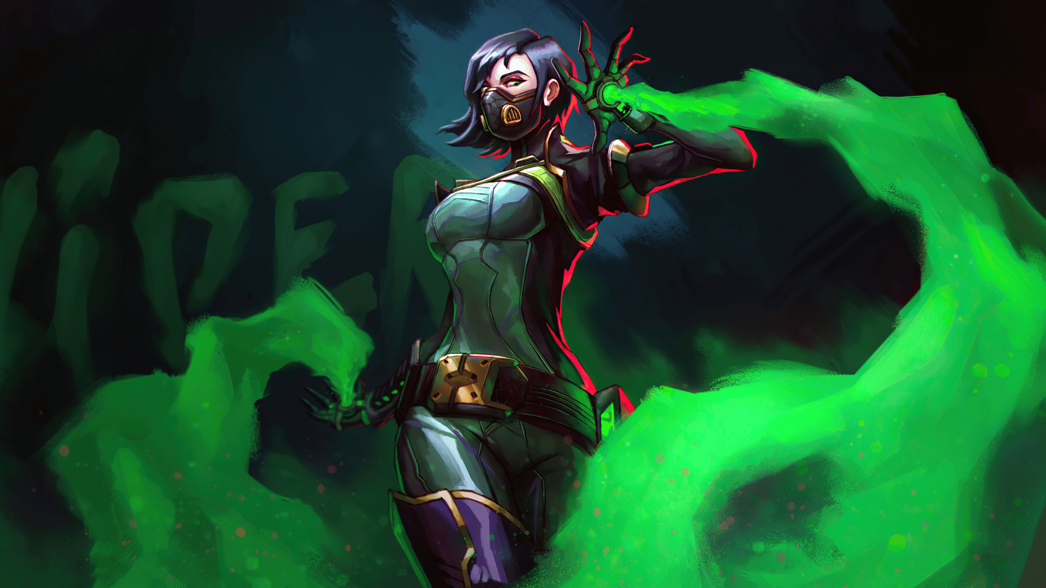

Link : <https://wallpapersden.com/viper-4k-valorant-2020-wallpaper/>

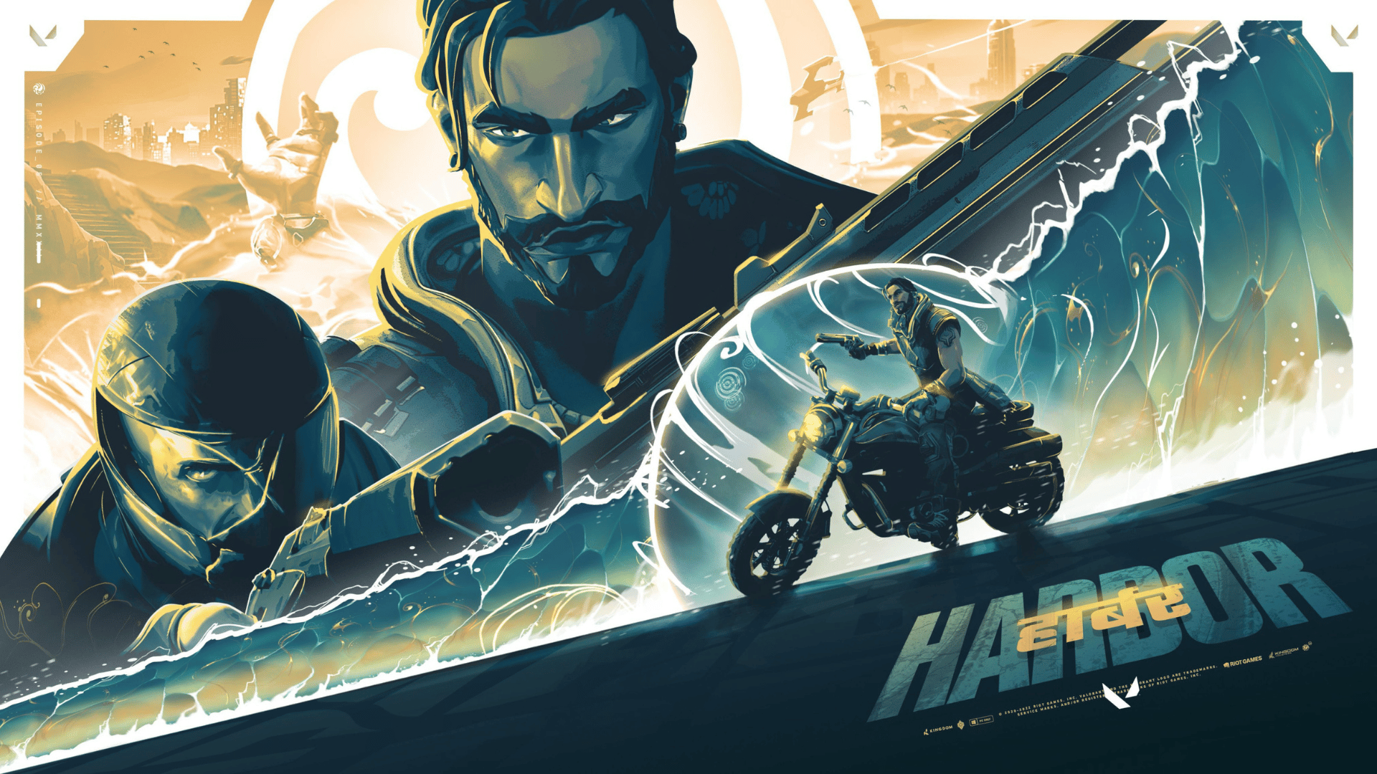

Link : <https://wallpapersden.com/harbor-cool-valorant-gaming-wallpaper/>

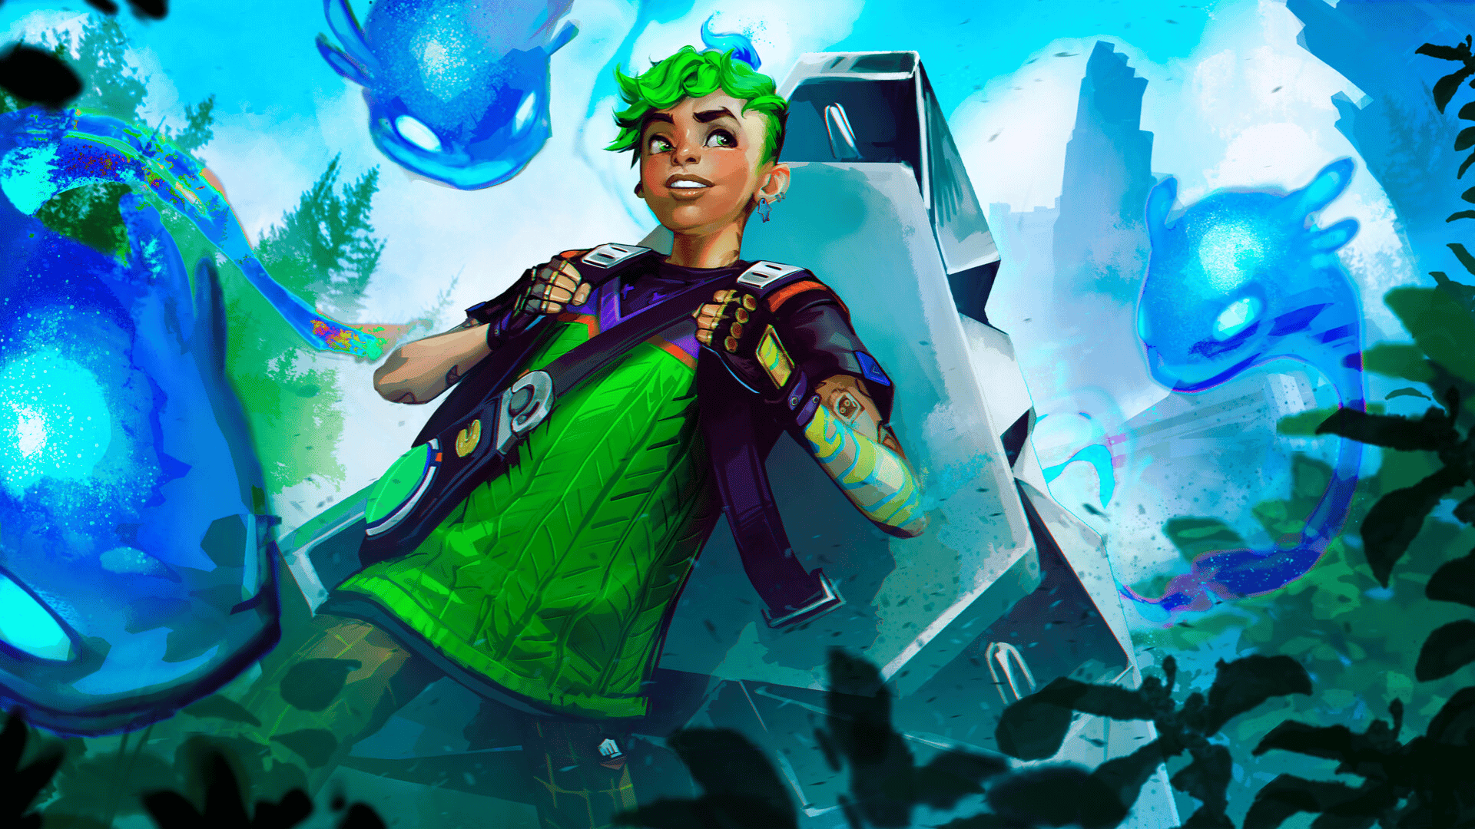

Link : <https://wallpapersden.com/gekko-hd-valorant-wallpaper/>

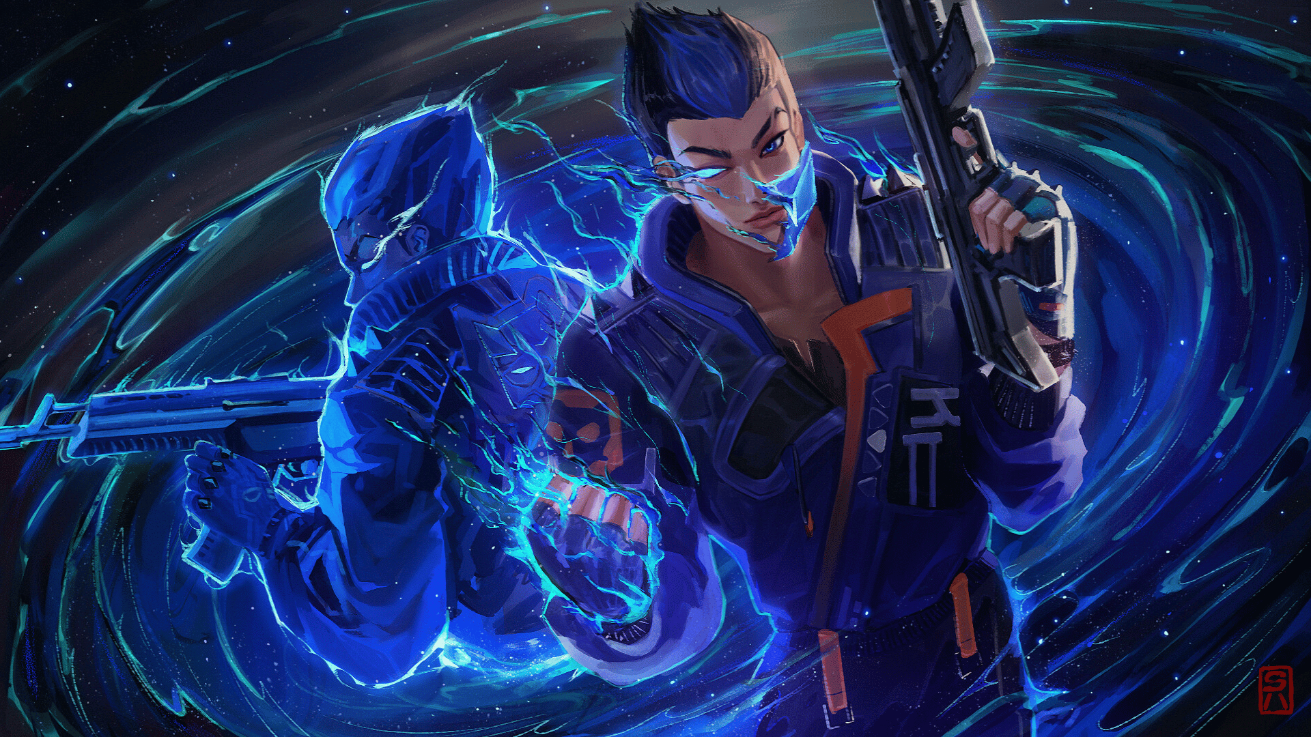

<https://wallpapersden.com/yoru-fan-art-valorant-wallpaper/>

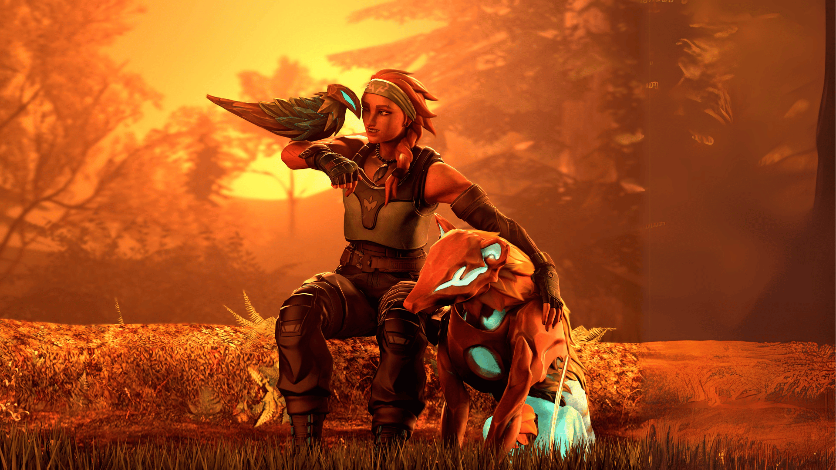

Link : <https://wallpapersden.com/skye-art-cool-valorant-wallpaper/>

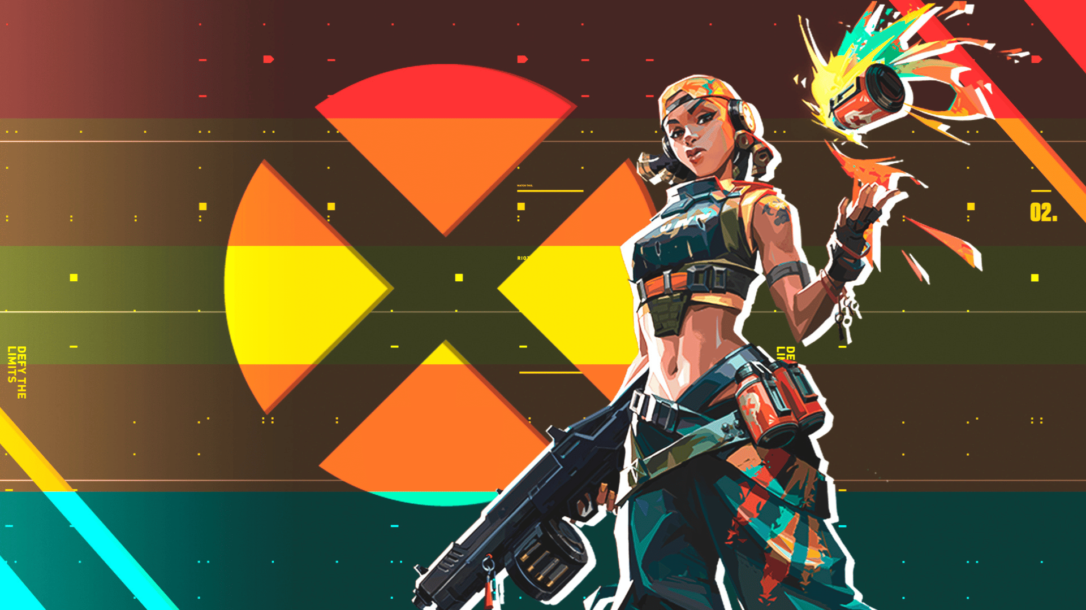

Link : <https://wallpapersden.com/raze-valorant-xbox-wallpaper/>

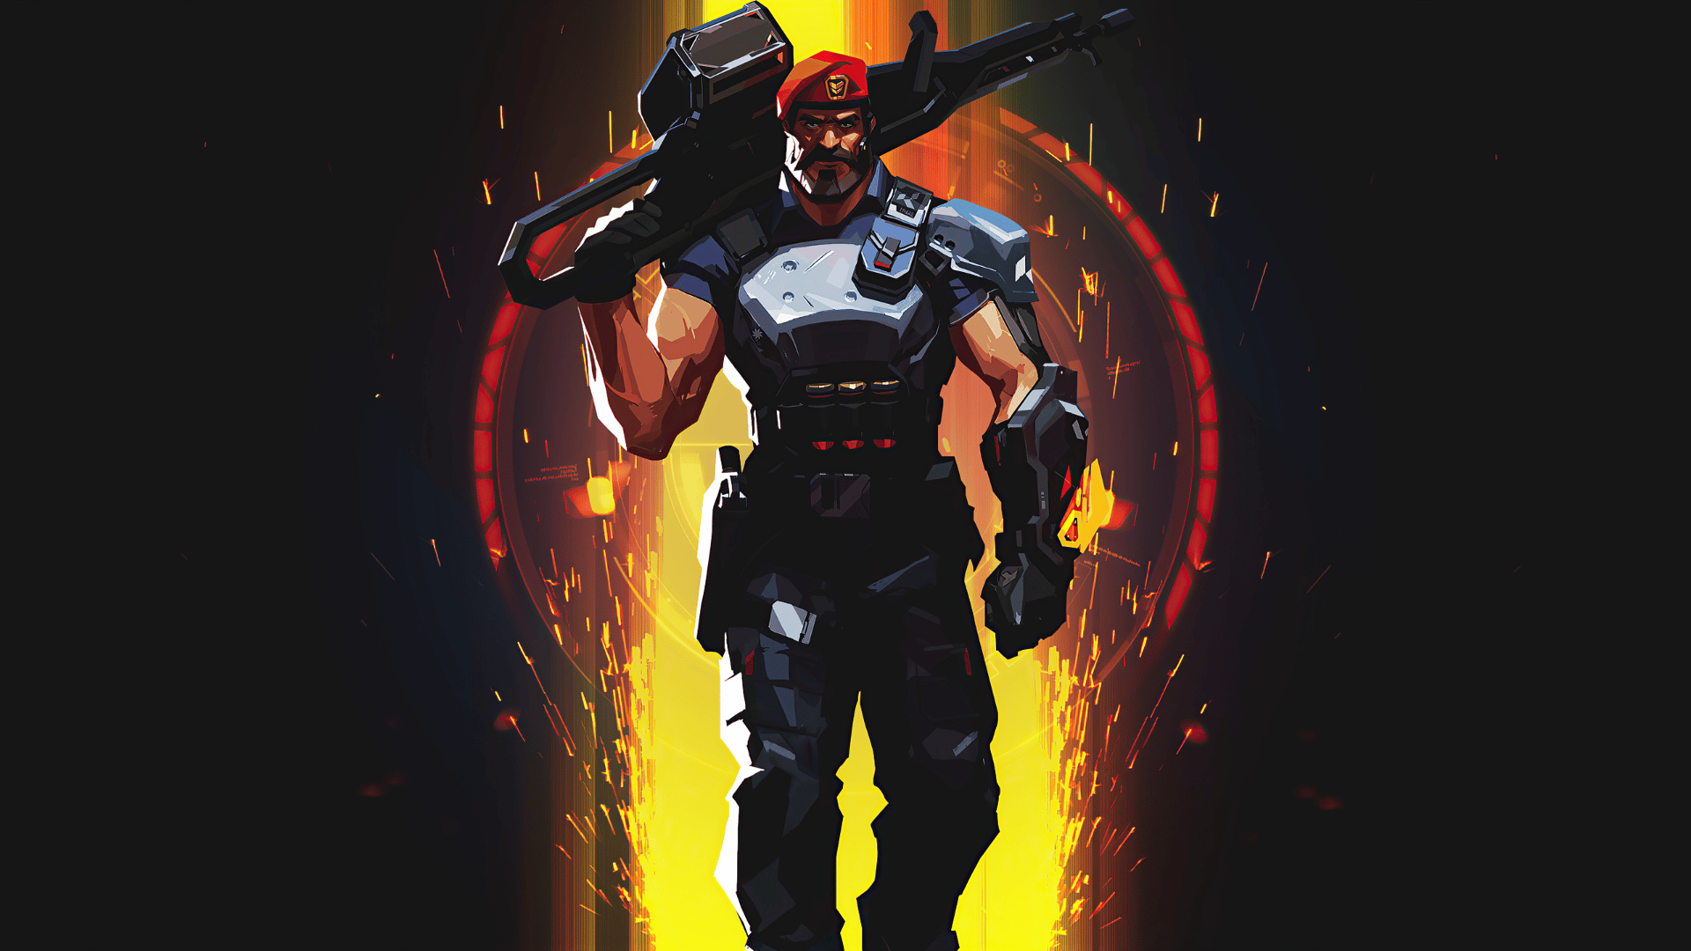

Link : <https://wallpapersden.com/brimstone-new-valorant-poster-wallpaper/>

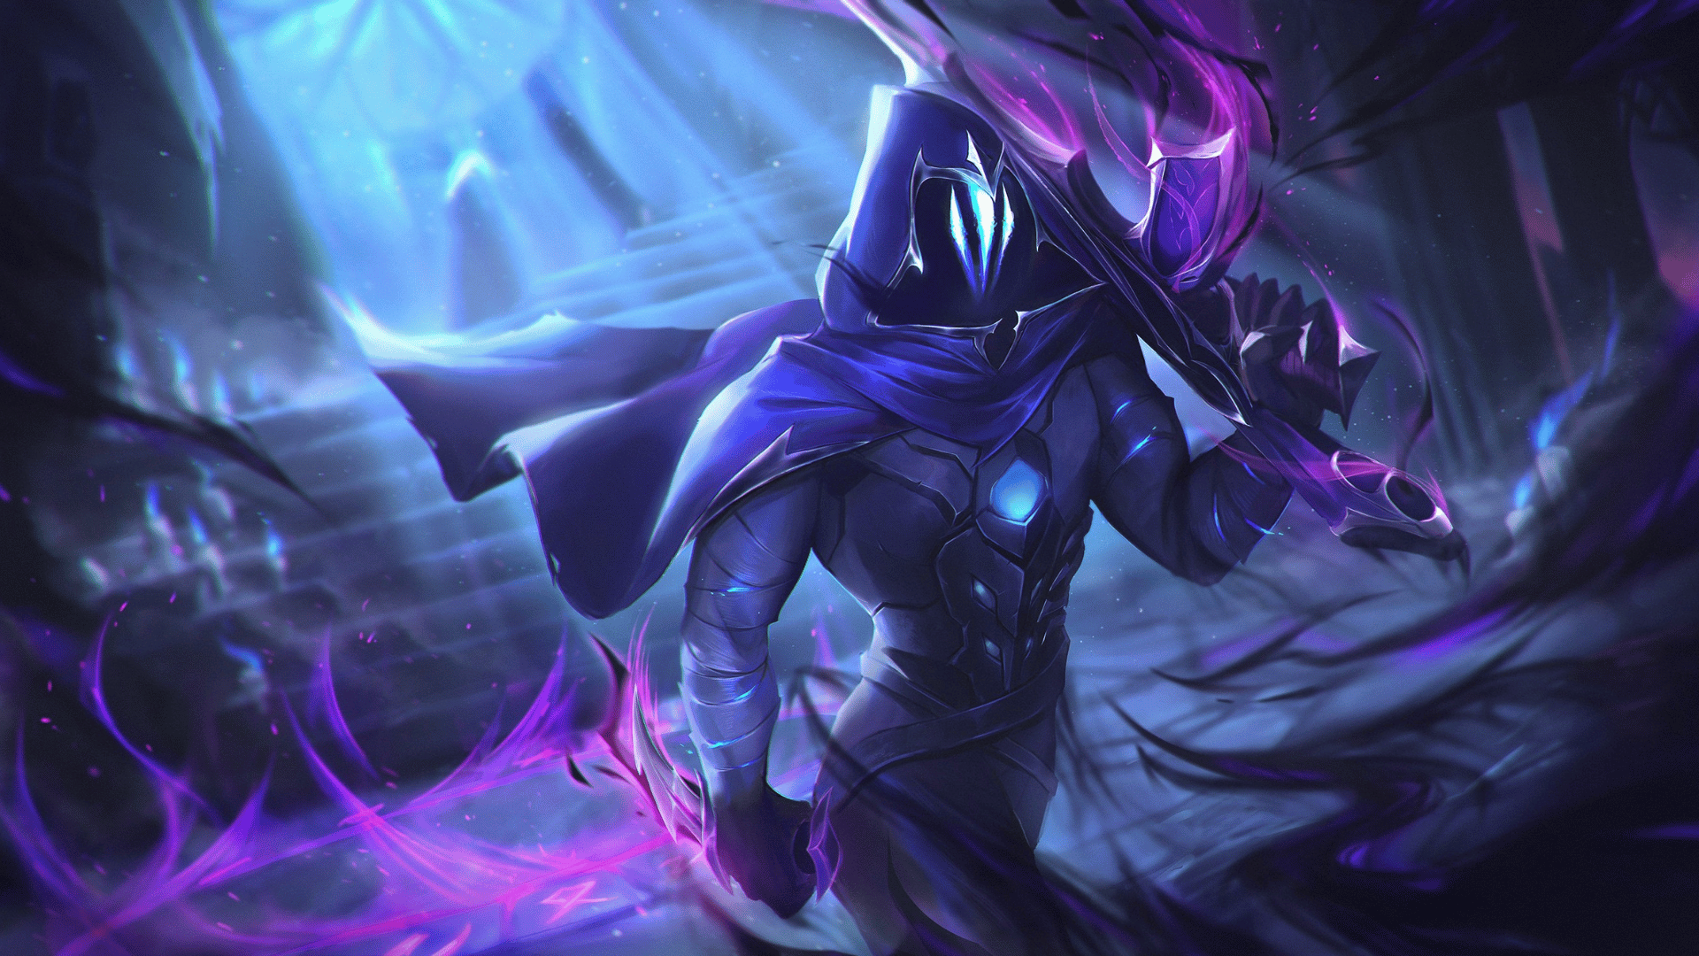

Link : <https://wallpapersden.com/cool-omen-valorant-2023-wallpaper/>

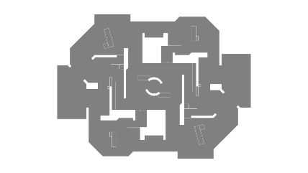

Link : <https://liquipedia.net/valorant/Kasbah>

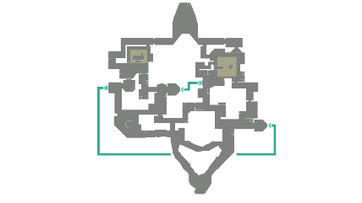

Link : <https://liquipedia.net/valorant/Bind>

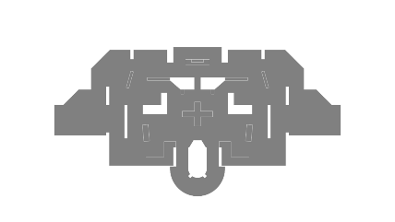

Link : <https://liquipedia.net/valorant/District>

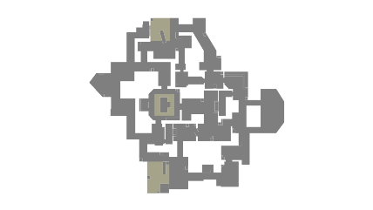

Link : <https://liquipedia.net/valorant/Haven>

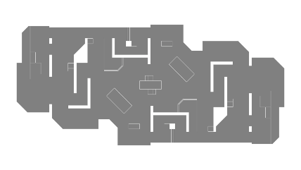

Link : <https://liquipedia.net/valorant/Piazza>

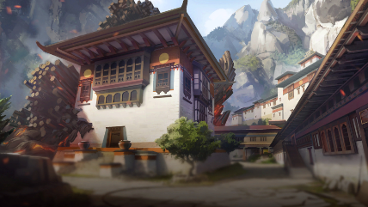

Link : <https://liquipedia.net/valorant/File:Haven_Map.png>

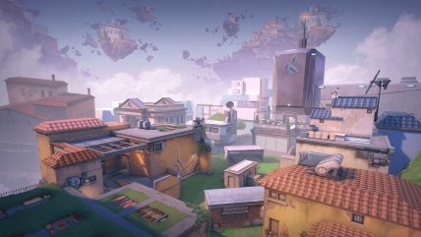

Link : <https://liquipedia.net/valorant/File:Piazza_Map.png>

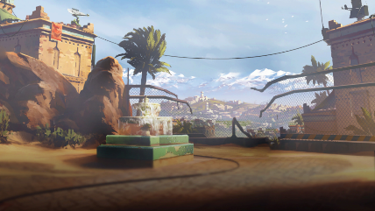

Link : <https://liquipedia.net/valorant/File:Bind_Map.png>

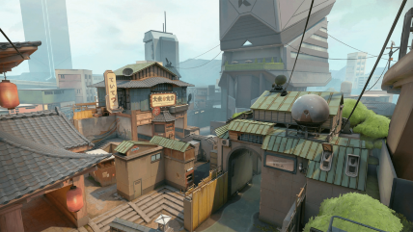

Link : <https://liquipedia.net/valorant/File:District_Map.png>

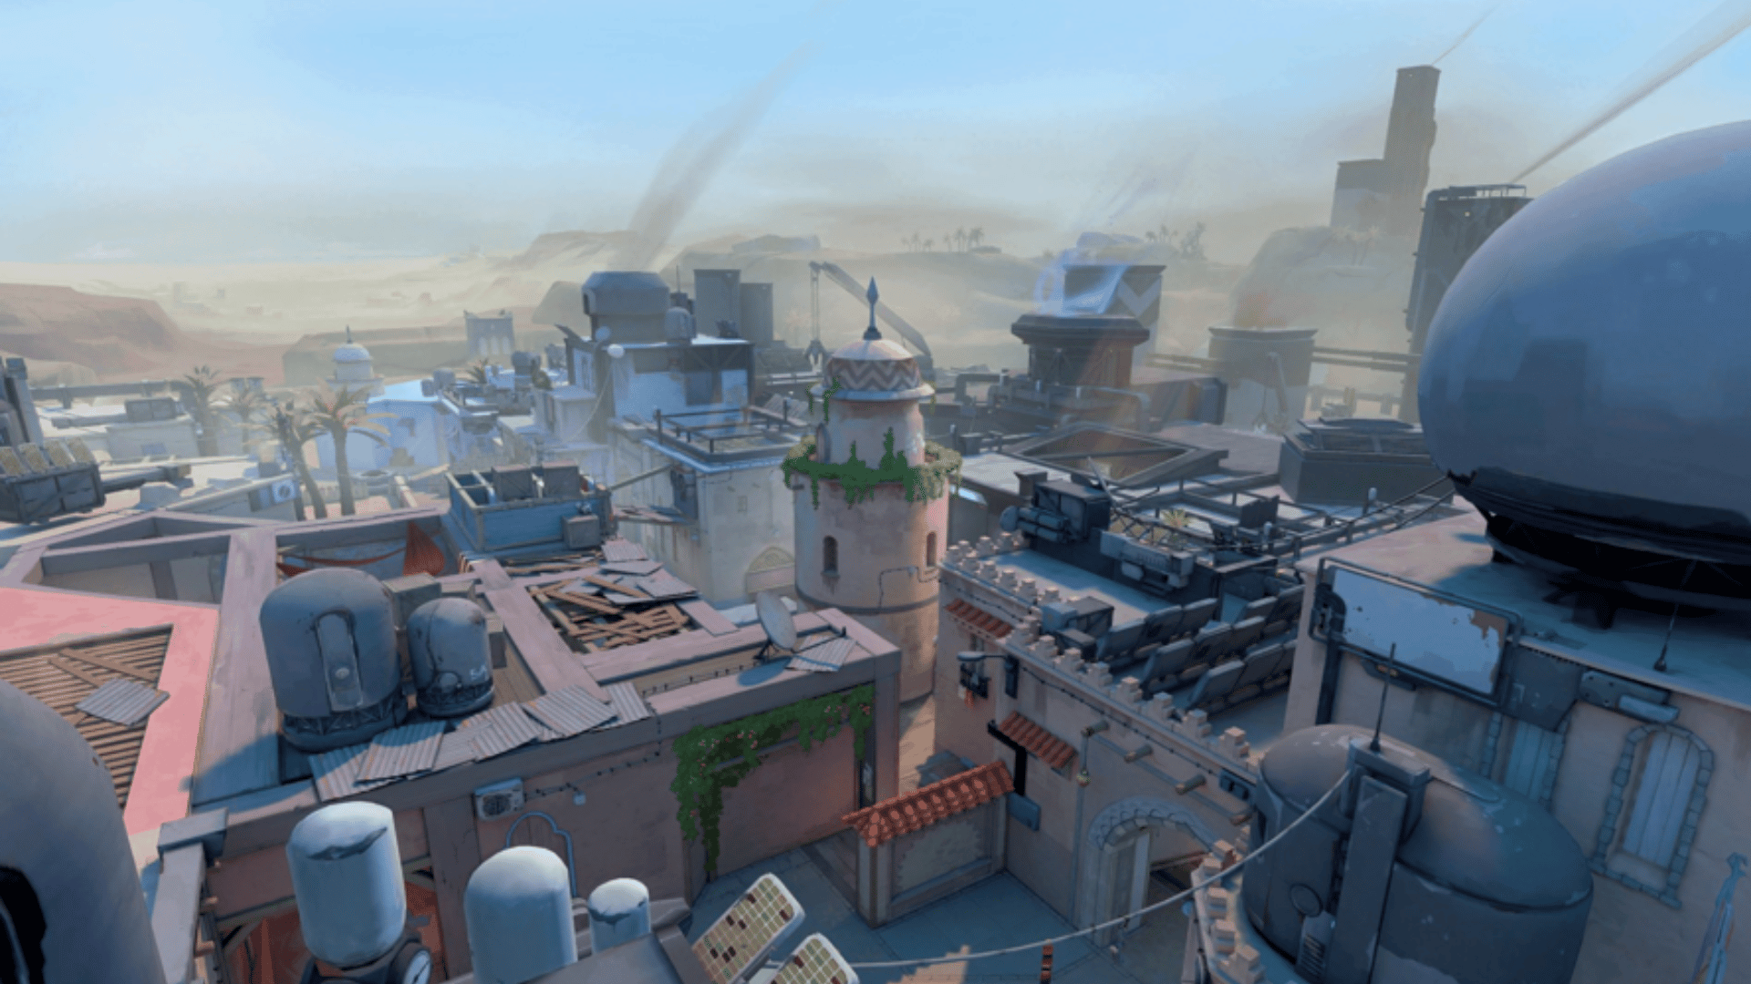

Link : <https://liquipedia.net/valorant/File:Kasbah_Map.png>

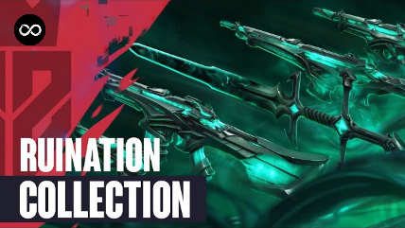

Link : <https://i.ytimg.com/vi/MDFwJXOG5-k/hq720.jpg?sqp=-oaymwEhCK4FEIIDSFryq4qpAxMIARUAAAAAGAElAADIQj0AgKJD&rs=AOn4CLAh8R4sNvR6PE3tpaxc_LfV_nuHuQ>

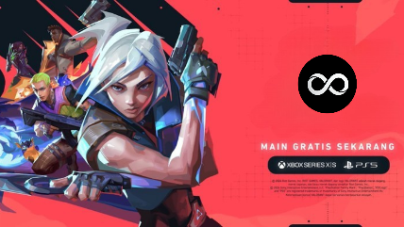

Link : <https://inet.detik.com/games-news/d-7474880/valorant-resmi-hadir-di-ps5-dan-xbox-series-x-s>

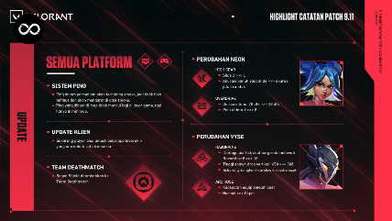

Link : <https://playvalorant.com/id-id/news/game-updates/valorant-patch-notes-9-11/>

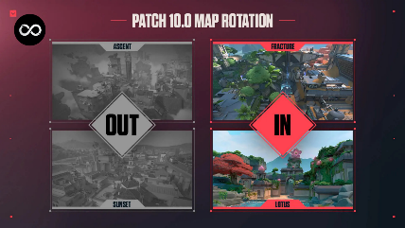

Link : <https://x.com/VALORANT/status/1859990737313493106>

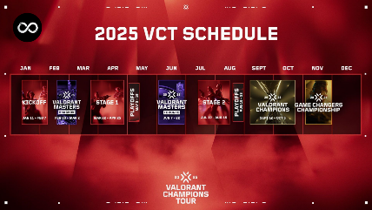

Link : <https://dailyspin.id/esports/valorant/valorant-champions-tour-vct-2025-pembaruan-dan-perubahan-penting/>

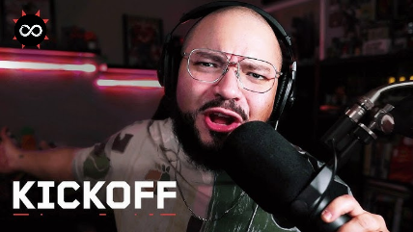

Link : <https://i.ytimg.com/vi/YU_1hne0HQc/hq720.jpg?sqp=-oaymwEhCK4FEIIDSFryq4qpAxMIARUAAAAAGAElAADIQj0AgKJD&rs=AOn4CLBZB3Qae-lpkUUn7xBI16kj6jQfJg>

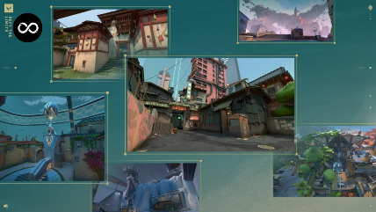

Link : <https://premate.gg/blog/how-to-improve-your-valorant-gameplay/>

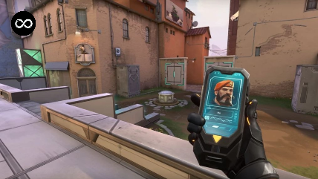

Link : <https://www.medcom.id/teknologi/game/5b2wo56k-valorant-luncurkan-fitur-flex-untuk-ekspresikan-gaya-pemain>



Link : <https://valorant.fandom.com/wiki/Reyna>



Link : <https://valorant.fandom.com/wiki/Jett>



Link : <https://valorant.fandom.com/wiki/Brimstone>



Link : <https://valorant.fandom.com/wiki/Sage>

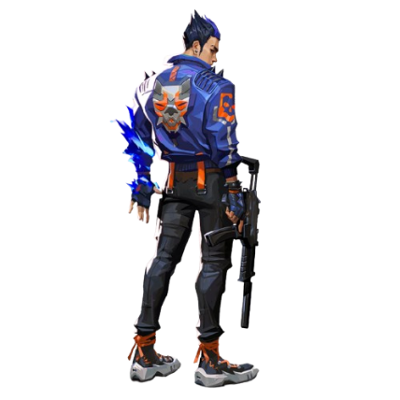

Link : <https://www.citypng.com/photo/16603/hd-valorant-game-yoru-agent-character-player-png>

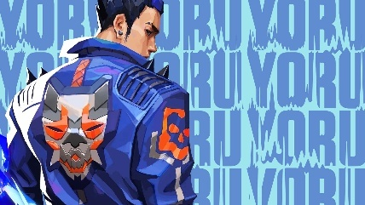

Link : <https://wall.alphacoders.com/big.php?i=1125089>

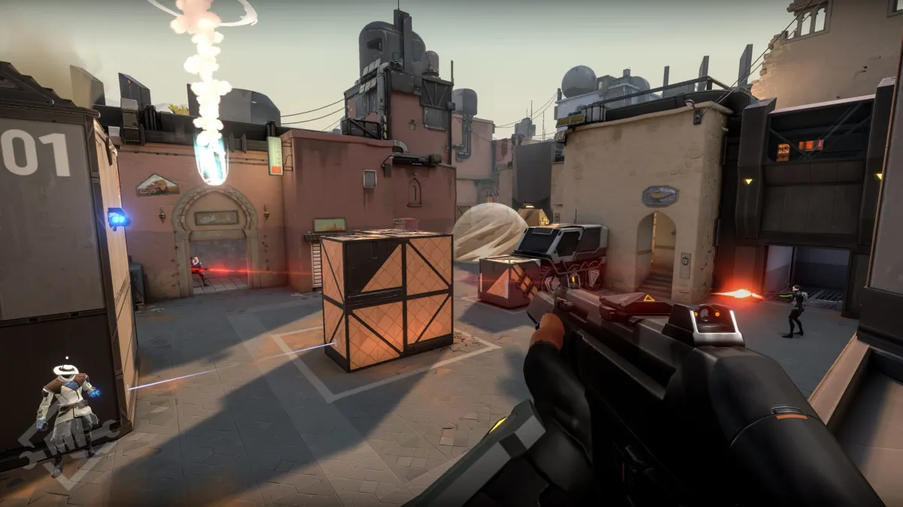

Link : <https://www.thegamer.com/valorant-game-best-worst-things/>

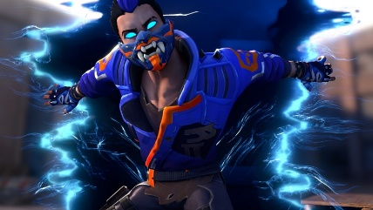

Link : <https://gamerant.com/valorant-yoru-guide-tips/>

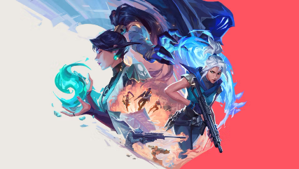

Link : <https://playvalorant.com/id-id/news/tags/cypher/>

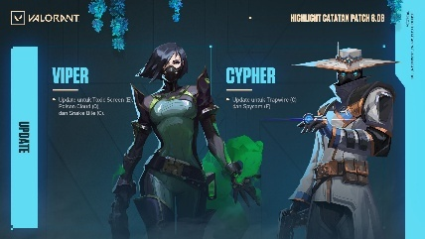

Link : <https://playvalorant.com/id-id/news/game-updates/valorant-patch-notes-8-08/>

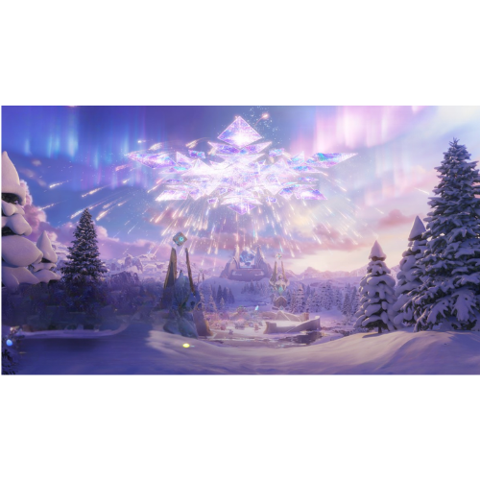

Link : <https://www.oneesports.id/honor-of-kings/event-winter-dreamland-hok-hadiah/>

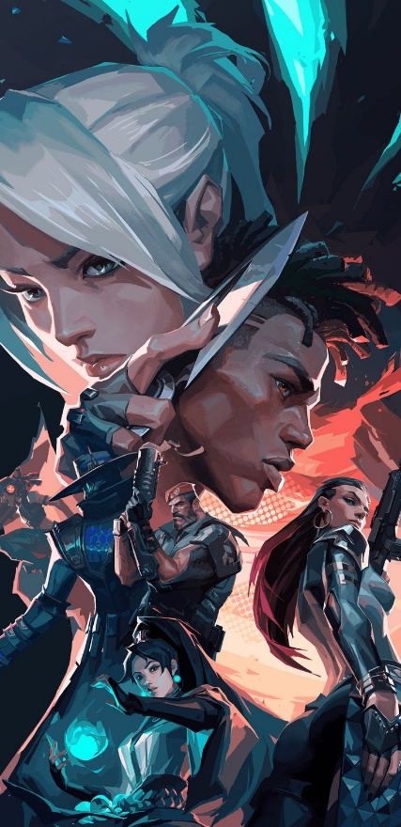

Link : <https://in.pinterest.com/pin/832110468645925643/>

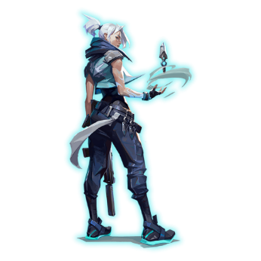

Link : <https://www.citypng.com/photo/6002/hd-jett-agent-valorant-character-png>

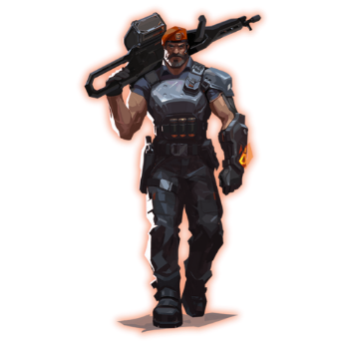

Link : <https://www.citypng.com/photo/5980/hd-brimstone-valorant-agent-player-character-png>

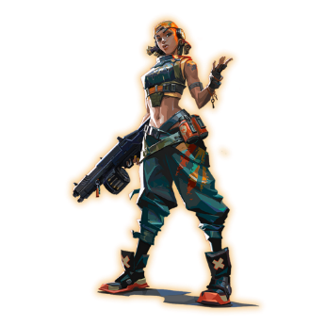

Link : <https://www.citypng.com/photo/7518/hd-raze-valorant-game-female-character-player-png>

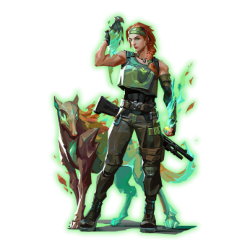

<https://www.citypng.com/photo/9604/hd-valorant-skye-female-agent-character-player-png>

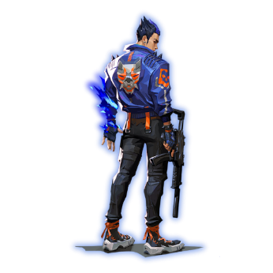

Link : <https://www.citypng.com/photo/16603/hd-valorant-game-yoru-agent-character-player-png>

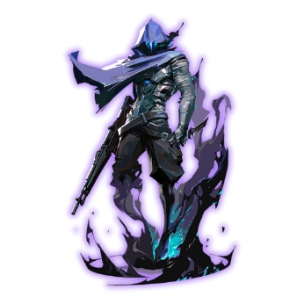

Link : <https://www.citypng.com/photo/7383/hd-valorant-game-omen-character-player-png>

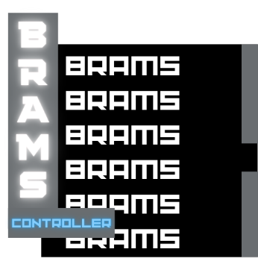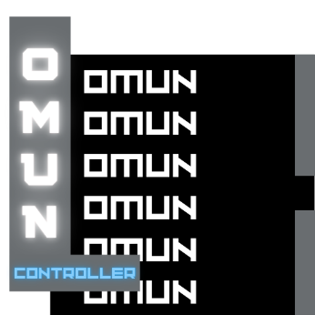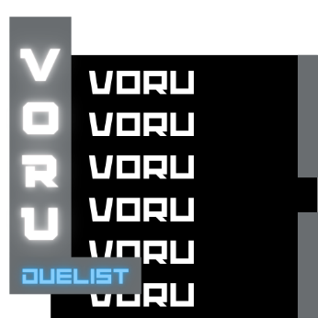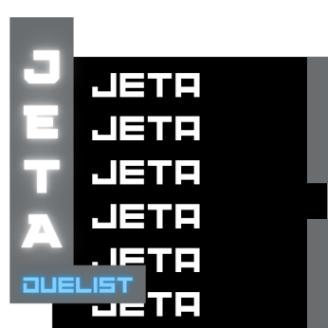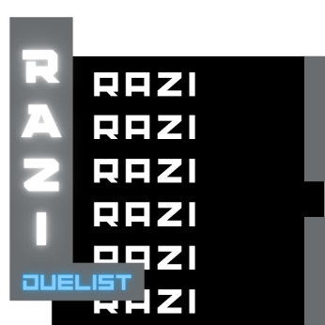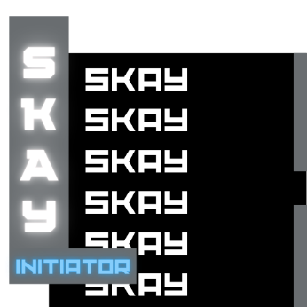

Saya membuat gambar ini di canva.

**FONT**

1. Lato-BoldItalic

Link : <https://fonts.google.com/specimen/Lato>

1. RacingSansOne-Regular

Link : <https://fonts.google.com/specimen/Racing+Sans+One>

1. Transformers Movie

Link : <http://dafont.com/transformers-movie.font>

1. Valorant

Link : <https://www.dafont.com/valorant.font>